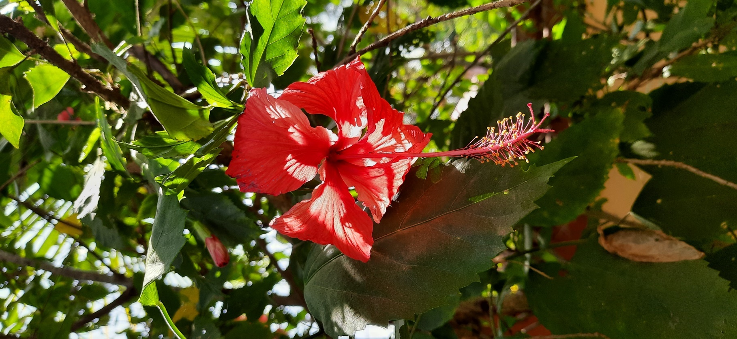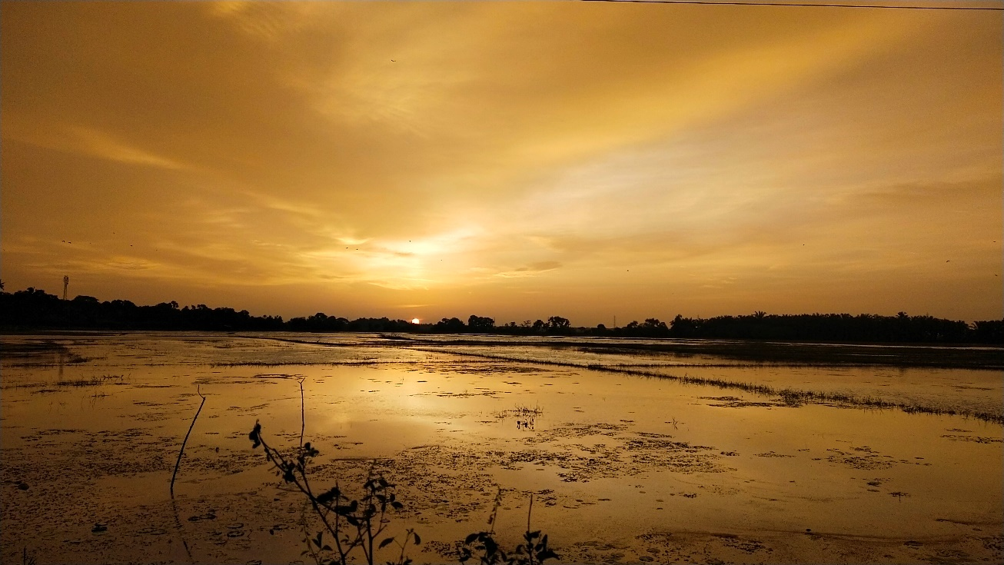

**Arnav Premchand**

**Madhav M Nair**

**A FRIENDSHIP IS A RIVER THAT FLOWS FOREVER**